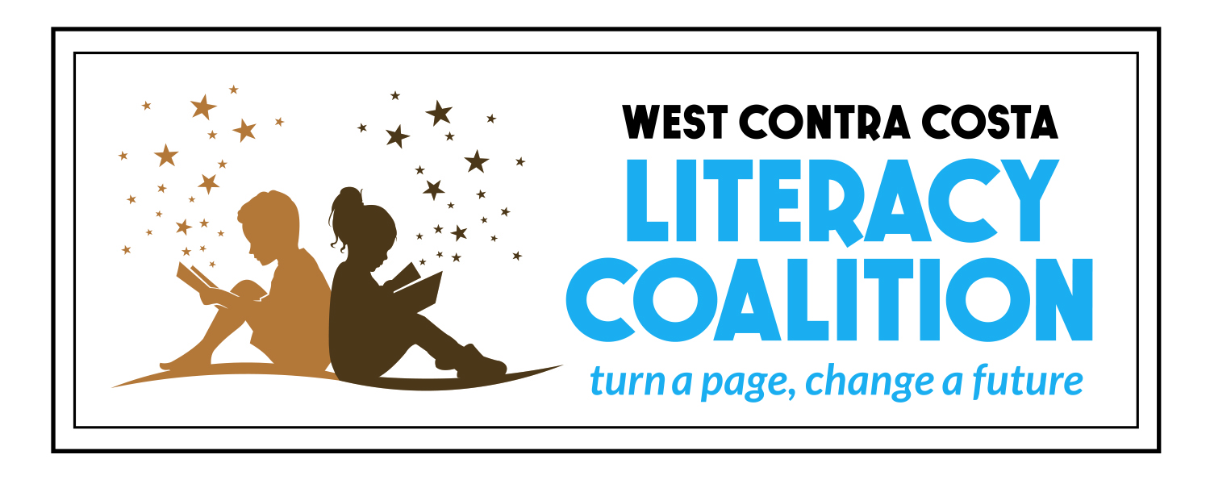

Request for Proposals
(RFP)
Summer Literacy Program Grants

Release Date:
April 5, 2017

Application Due Date:
April 21, 2017, 5:00 PM

Please send completed applications to:
Monica Lazo, Director of Grants Management
mlazo@richmondcf.org
(510) 234-1200, ext 306

For questions about Summer Literacy Programs*, contact:
Shabnaz Yousefia, Director of Community Engagement
syousefia@richmondcf.org
(510) 234-1200, ext 305
*Note- all questions must be received before April 19, 2017
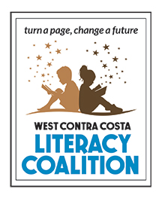

Introduction
The West Contra Costa Literacy Coalition and the Richmond Community Foundation, with generous support from the Hellman Foundation and the Ed Fund, are pleased to announce a Summer Literacy Grant Opportunity for grants ranging from $5,000-10,000. The purpose of these grants is to support the growth of summer literacy programs in West County by:

- Creating a literacy component in existing summer programs
- Creating slots for, and ensuring that, an additional 1,000 students enroll in summer literacy programs in West Contra Costa County

These grants will support a comprehensive plan to ensure that all children will read on grade level by the end of the 3rd grade.

Background
Summer learning loss, the phenomenon where young people lose academic skills over the summer, is one of the most significant causes of the achievement gap between lower and higher income youth and one of the strongest contributors to the high school dropout rate. For many young people, the summer “opportunity gap” contributes to gaps in achievement, employment and college and career success.

According to the National Summer Learning Association, low-income youth lose two to three months in reading every summer, while their higher-income peers make slight gains. Research shows that this reading loss adds up. By fifth grade, summer learning loss can leave low-income students 2 ½ to 3 years behind their peers.

A Needs Assessment conducted in 2016 by the West Contra Costa Literacy Coalition shows that out of the approximately 10,280 children ages 0-9 in Richmond who are in need of quality summer literacy programs, less than 1,700 children have access to them.

The Literacy Coalition has identified summer learning as one of the largest needs in our community. Our goal is to support an additional 1,000 children to enroll in high quality literacy programs in summer 2017.

Eligibility
Eligible applicants are those defined as:
- Public, tax-exempt organizations by Section 501(c)(3) of the Internal Revenue Code, or have a fiscal agent that is;
- Providing services to Richmond residents;
- Having a Board of Directors;
- Having filed current 990 tax forms.

Restrictions
The Richmond Community Foundation does not make grants in support of individuals, for political campaigns or lobbying efforts, for businesses established for personal gain or profit, to support annual fund drives, capital campaigns, to fund an agency’s deficit or endowment, to repay loans, to pay for expenses incurred in the past, or for the direct support of religious activities. Secular activities offered to the community that are provided by religious organizations regardless of congregational membership or statements of belief may be eligible for grant funds.

Organizations may submit only one application in response to this proposal. In addition to requesting funds for its own purposes, organizations may also act as fiscal agents for no more than one additional group.

How to Apply
Complete applications are to be submitted by email to Monica Lazo, Director of Grants Management at mlazo@richmondcf.org, or by US mail to:

Richmond Community Foundation
Attn: Monica Lazo, Director of Grants Management
1014 Florida Avenue, Suite 200
Richmond, CA 94804

Richmond Community Foundation
Summer Literacy Grant Proposal
Deadline: April 21, 2017, by 5:00pm

REQUEST SUMMARY

Name of Organization: __________________________________________________________

Address: ______________________________________________________________________

Contact person and title: ________________________________________________________

Telephone: __________________________ E-mail: ____________________________

Website: ________________________________________________

Tax ID Number: ________________________________________________

Fiscal Sponsor?

Are you applying as an individual? Yes or No (circle one)
If yes, who is your fiscal sponsor? __________________________________________________________________

Fiscal Sponsor contact person: _____________________________________________________________________

Phone and email address:_________________________________________________________________________

Number of learners who will benefit from the proposed project: _______________________

Amount requested: _______________________

*******************************************************************************************

BUDGET
Please attach a detailed budget for your proposed summer program. The budget for your proposal should be clear, well organized and easy to understand. Consider using a spreadsheet with the following categories:

1) Budget Category with detailed expenses for personnel, supplies and food
2) Requested Funds
3) Outside Contributions
4) Project Total

PROPOSAL
The proposal length should not surpass 4 typed, easily readable pages, i.e., font size 11 pt. or larger with at least 1.5 lines spacing. The Request Summary and Budget do not count toward the four page limit.

1. Your Program’s Teaching Philosophy and Practices

- Program Philosophy
  - Describe your program’s theory of literacy.

- Description of Program
- Please describe your proposed project and the activities that will take place. Include projected dates, hours and location of proposed activities.
- Is this the first time you are incorporating literacy into your summer program? If so, how do you plan to do this?
- Do you plan to serve parents? If so, how will you engage parents to support the learner’s progress?

- Community Partners
  - Describe how you will work with other community partners to implement this program. Please name all partners/organizations.
  - What is the proposed location where your program will take place?

- Population Served:
  - Approximately how many students does your program plan to serve? If applicable, how many parents/families do you seek to serve?
- Who are your targeted learners? What age group do you seek to serve (ages 0-5 or 6-9)?
  - How will you collect demographic information for your participants?
  - Do you plan to increase your numbers of students served from the previous year(s)? By how much?
    - How do you plan to recruit participants?

- Goals, Timeline and Evaluation of Project

- Goals
  - List your measurable literacy goals for your project. How will the attainment of these literacy goals benefit your learners?

- Timeline
  - Present your timeline for implementing each goal. Include key activities, measurable benchmarks, important dates, and deadlines.

- Evaluation of project and Student Progress
- How will you document attainment of your stated literacy goals for your project?
- How will you know that you have met these goals?
- What methods do you use to assess literacy progress? Would you be willing to add a pre/post survey to your program assessment?

5. CHECKLIST

[ ] Request Summary

[ ] Summer Literacy Proposal

[ ] Budget for your project

[ ] Most recent IRS 990

[ ] Copy of 501 (C)(3) IRS determination letter

