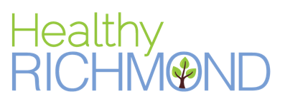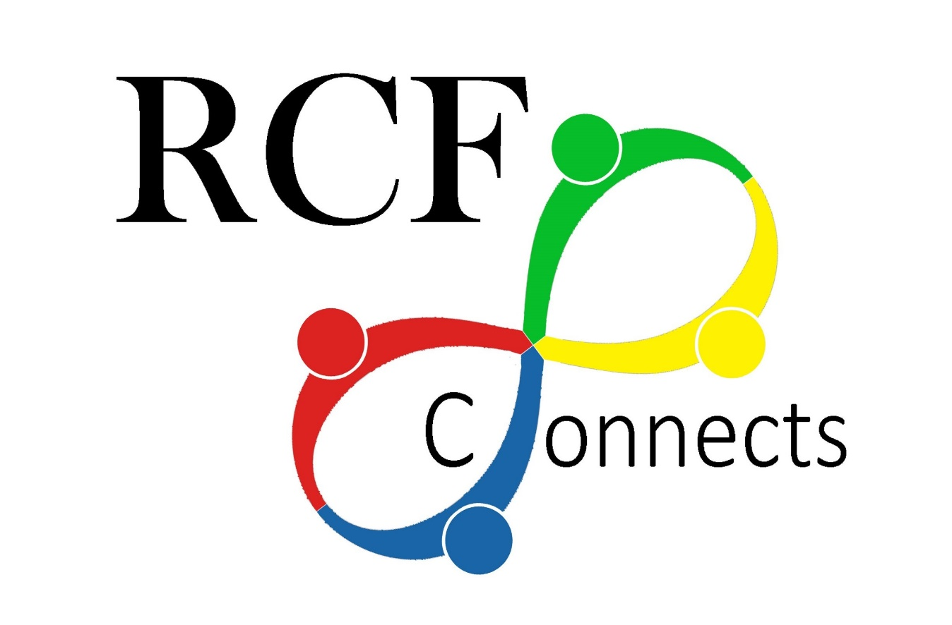
Job Title: Project Manager- Resident Leadership
Reports to: Healthy Richmond Senior Director

RCF Connects (formerly Richmond Community Foundation) strives for healthy, thriving communities that are safe and diverse, and where families flourish and children are given new hope for a bright and abundant future. RCF Connects partners with the community to inspire leadership and share the vision for work in five areas: Community Growth, Health, Restoring Neighborhoods, Education, and Public Safety. Our work is driven by a deep commitment to working with the communities we serve to strengthen economic, racial, cultural and social equity. This commitment is expressed both in the outcomes we are striving for and the ways in which we do our work. To learn more, please visit http://www.rcfconnects.org/.

Project Background & Description:
The Healthy Richmond initiative is part The California Endowment (TCE) -funded statewide effort known as Building Healthy Communities (BHC). Through BHC, TCE learned that activism, advocacy, community organizing, and civic participation to build people power has a significant and meaningful impact on the community and environmental conditions that affect health. The Healthy Richmond (HR) “Hub” is committed to racial & health equity and actively supports collective campaign strategies that aim to shift systems policy and practice to benefit low-income communities and communicates of color. The initiative is in year 8 of a 10-year TCE funded effort. The resident and partner leadership within the Healthy Richmond Hub will be designing a sustainability plan over the next 6 months to design a new organizational structure and collective plan to implement beyond 2021. RCF Connects is the host agency for Healthy Richmond RCF’s intent is to enable the operation of a strong, integrated partnership with its initiatives. RCF will employ key staff who will provide ongoing support and coordination for the work of the Healthy Richmond Initiative.

Position Description:
Assumes responsibility for the implementation of a single program, ensuring compliance with stated objectives of the project. Coordinates the work of others within the program; works with other initiatives as necessary. Healthy Richmond seeks a full-time Project Manager who will support functions related to our Healthy Richmond (HR) Initiative including community organizing activities focused on resident power building, project coordination tasks related to HR collective meetings and events, communications and other duties as assigned. The HR Initiative is dedicated to addressing physical, social, and economic factors and systems by working with multiple sectors and stakeholders, from individuals to large public systems. This position will report to the Healthy Richmond Senior Director and is based in our Richmond office.
Responsibilities
- Responsible for staffing resident-led campaign activities in the areas of community development, access to healthcare and education.
- Facilitation of the development and implementation of resident leadership strategies, including resident and youth capacity to engage and lead policy advocacy and systems work; and increase leadership in Healthy Richmond activities and the community in general.
- Provide programmatic support for Action Team and campaign meetings for which they have a lead responsibility- including scheduling, location set up, meeting prep support, processing agendas and minutes, communications to partners (reminder emails, action items, follow-up).
- Provide logistic and program support for HR special events including but not limited to quarterly Steering Committee and other organized events.
- Provide general administrative management functions such as processing invoices and project expenses, and general office supply orders.
- Provide Grants Management Coordination, including but not limited to working with RCF Connects staff to process HR grant awards, coordinating grant disbursement requests, overseeing and following up with grantees to submit narrative/outcome reports to funders, track and monitor draw down of funds.
- Provide coordination and assist in responding to funder reporting requirements.
- Ensures that Healthy Richmond collaborative members are connected via on-line platforms such as Facebook, Outlook, and other appropriate means, and that information is distributed to all members of the Hub collaborative, including those without Internet access and whose primary language is not English.
- Maintain a flexible work schedule, as meetings and events will occur outside normal office hours, including evenings and weekends. Some travel outside the Richmond area will also be required.

QUALIFICATIONS:
- Bachelor’s degree preferably in Public Policy, Public Health, Social Welfare, or 2 years of relevant experience in community organizing, policy advocacy, and/or public health prevention focused initiatives.
- Minimum of 2 years of relevant experience in community organizing, policy advocacy, and/or public health prevention focused initiatives.
- Some experience working in non-profit, government, or public sectors; experience in working across sectors and low income communities is highly desirable.
- Process facilitation capacity, including the ability to set meeting agendas and goals, manage complex relationships and resolve conflict.
- Project management skills including ability to guide vision and strategy, advance policy and support aligned activities, and have excellent written and oral communication skills.
- Self-motivated, reliable and strong interest in committing to the HR Initiative’s work.
- Some knowledge of the economic, political and social environments of Richmond.
- Ability to be flexible, multi-task, plan and prioritize workload and work in fast-paced environment.
- Strong professional caliber communication skills with proficiency in using multiple social media channels including, but not limited to Facebook, Twitter, interactive web sites and blogs. Some understanding of underlying principles for the use of media advocacy utilizing social media to promote community organizing and policy advocacy goals.
- Ability to compose, edit, design and produce communications including flyers and event invitations.
- Proficiency with Microsoft Office Suite.
- Able to work with diverse community members including the ability to effectively create alliances between groups.
- Bilingual in Spanish and ability to perform interpretation and written translation is highly preferred.
- Have access to reliable transportation and willing to use it for job related tasks.

COMPENSATION:
RCF offers a competitive salary and excellent benefits.

Please send cover letter and resume via e-mail to:
Stacey Street
sstreet@richmondcf.org
RCF Connects is an equal opportunity employer and does not discriminate on the basis of race, color, religion, sex, age, national origin, veteran status, physical or mental disability, or sexual orientation.

