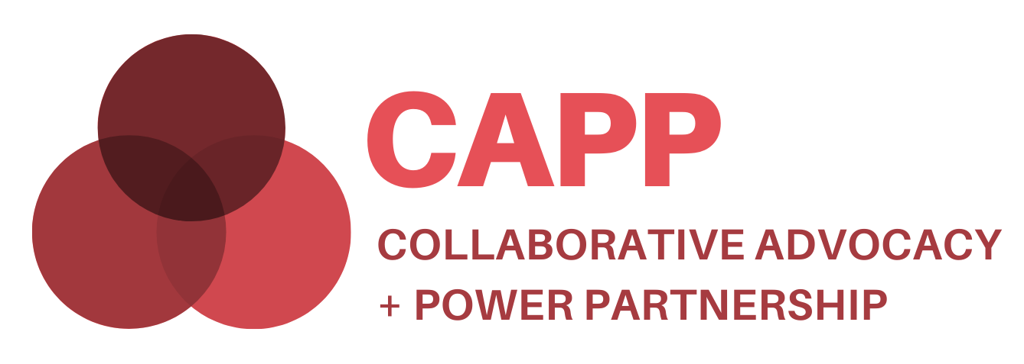
Benefits of Participating and What to Expect

The Ensuring Opportunity Campaign to End Poverty in Contra Costa County (EO) and First 5 Contra Costa’s Family Economic Security Partnership (FESP) are launching the Collaborative Advocacy + Power Partnership (CAPP) to enhance the capacity and deepen the impact of policy and systems advocacy in Contra Costa County. The objective of CAPP is to build a broader, better-connected, and more powerful base of community organizations and residents to advocate for policies and systems that increase equity in Contra Costa. CAPP is housed at RCF Connects, which also serves as the host organization for Ensuring Opportunity. Initial funding for CAPP is generously provided by the San Francisco Foundation.
What can I expect as a CAPP cohort member?
You will join a cohort of people who live and/or work in Contra Costa, and who -- like you -- are passionate about creating a community where everyone belongs, and where all residents, regardless of income, race or any other factors, have the support and opportunities they need to thrive. For 9 months, starting in July 2021, you will work with your colleagues to identify community needs, learn from experts, share your own expertise, and plan a joint advocacy campaign.

Who is invited to participate?
Three different constituencies will form a cohort and work collaboratively: direct service providers, advocacy organizations/coalitions, and residents affected by economic and racial inequities.
For direct service providers:
- We are seeking a diverse group of up to 10 direct service providers that are motivated to learn and move into action. We welcome organizations working on a variety of issues related to economic, social and racial justice, such as housing, early childhood, economic security, food security, criminal justice reform, safety net, health equity, immigrant rights, justice reform, the arts, and senior services.
- Each service provider organization is asked to bring a team that includes a manager, line worker, resident constituent, and board member to the table (board member participation can be limited to key points). We welcome and encourage organizations of all sizes to participate, so if capacity is a concern, please reach out to us.
For advocates:
- We are seeking up to 10 advocacy organizations (501 c3s and c4s) that are already engaged in advocacy and community organizing, and that want to share advice and strategies, deepen system shifts, find new allies, and expand collaboration within and across issue areas. Advocacy organizations are encouraged to invite a resident leader to participate.
For residents:
- We welcome up to 20 residents with lived experience with economic/racial inequities, who may or may not currently be affiliated with any organization or campaign in Contra Costa.

What is the time commitment?
We recognize that this is a serious commitment of time. We want to thank and honor those willing to make this investment. CAPP is a 9-month program, commencing in July 2021 and finishing in March 2022, with the option to continue into the program’s second year to implement the joint advocacy campaign. Time commitments for the first year include two half-day retreat, monthly 3-hour cohort meetings, and an average of 5 additional hours/month for outside assignments. Initial sessions will be held on Zoom; later sessions may be held in person. Participants will benefit the most, both individually and as a cohort, when all members are present at each meeting. Each session builds on the prior ones, and the program is designed to be deeply interactive. Accommodations will be considered to enable full participation by all cohort members.

Who will facilitate and oversee this project?
A CAPP Steering Committee, including several cohort members as well as external experts and stakeholders, will advise on curriculum content, participant support, and other aspects of creating a successful learning experience. An external consultant will facilitate cohort meetings and manage the day-to-day details of the program. The project co-leads (EO and FESP) share ultimate responsibility for ensuring project objectives are achieved.

What are the project’s overall goals?
- Build a broader, better-connected, and more powerful base of CBOs, residents, and allies to advocate for policies and systems that increase equity in Contra Costa.
- Increase understanding of the distinction between individual and system-level advocacy/lobbying.
- Encourage collective advocacy and coordinated action, disrupting the long-standing pattern of siloed efforts.
- Identify narrative change needs and strategies that can build public will for systemic solutions to injustice.
- Identify joint policy goals for the cohort’s second-year implementation of a joint advocacy campaign.
What do we mean by advocacy?
Advocacy refers to activities that people and organizations engage in to change or support public policies. There are a wide range of activities that are considered advocacy, including conducting research, educating the public, influencing regulations, educating legislators, training leaders, lobbying decision makers, educating and registering voters, and organizing community residents to advocate for needed changes.
What are the program components?
A variety of actions will occur including: conversations to invite diverse perspectives; organizational self-assessments; sharing of models and best practices for advocacy engagement; reading assignments and discussions; presentations by experts in advocacy, public budgets, systems change, racial equity, and narrative change; power mapping of specific issues and systems; coaching (one-on-one and group) and mentorship; surveys and interactive polls; and community-building activities.
Is there any funding for cohort participants?
- Each participating organization will receive a $1,500 organizational stipend. Every resident, whether participating independently or as part of an organizational team, will receive an individual $1,500 stipend. Steering Committee members will receive an individual stipend of $1,000.
Additional questions? We encourage you to reach out to Mariana Moore, Senior Director of Ensuring Opportunity, at mmoore@richmondcf.org; or Fran Biderman, Special Projects Coordinator, First 5 Contra Costa/FESP, at fbiderman@first5coco.org.

